Week 5 Individual Logbook
Capstone project
Matt Baker
2026
Table of Contents
Hours Breakdown 2
Completed Content/Documentation 3
Team Meetings 3
Advisor Meetings 3
Client Meetings 3
Research 3
Documentation 3
Testing 4
Development 14

Hours Breakdown
Category | Hours completed
Team meetings | 2hrs 15 mins
Client meetings
Advisor meetings
Research | 2hrs 45 mins
Development
Testing | 19 hrs 15 mins
Documentation | 15 mins
Logbook preparation | 1 hr
Sick leave/specific conditions
Other
Total Hours for this week | 25hrs 30mins
Running total of hours completed for  Capstone | 71hrs 45min/450hrs

Completed Content/Documentation

Team Meetings
Tuesday, August 11
11-12:30pm (1hr 30 mins)
Lots of auditing, working out the agenda for the week, what Sam and Dave can work on, how to find hours, delegating work, a tool for each of us to fiddle with.
Friday, August 14
2:00-2:45 (45 minutes)
Coming up with tasks to put on the Trello board for Kanban, discussion of the testing process.

Advisor Meetings

Client Meetings

Research
2hrs 45 mins
Research this week was focused on finding AI based forensics tools, inspecting their documentation, and using this to troubleshoot errors. I also used some time to begin producing a table of AI/Non-AI DFIR tools.
(see research log)

Documentation
Wednesday, August 12
10:00-10:15AM (15mins)
Digitized, improved, and pushed the team meeting minutes from yesterday

Testing
Monday, August 10
12:30-2:00PM (1hr 30mins)
Setting up a kali VM install on my own home PC for local testing, tools practice, and as a contingency if for whatever reason we are not able to work on our dedicated PC at school. This will also mean that we can conduct investigations in parallel with each other if access to our AI PC is contested.
2:00-4:00PM (2hrs)
Doing some refamiliarization with exiftool on files, testing different types of photos/screenshots to pull gps data from my own phone, even if I try to dox myself by attaching the location to an image, exiftool will generate the field, but the data will be missing (export process strips metadata?).
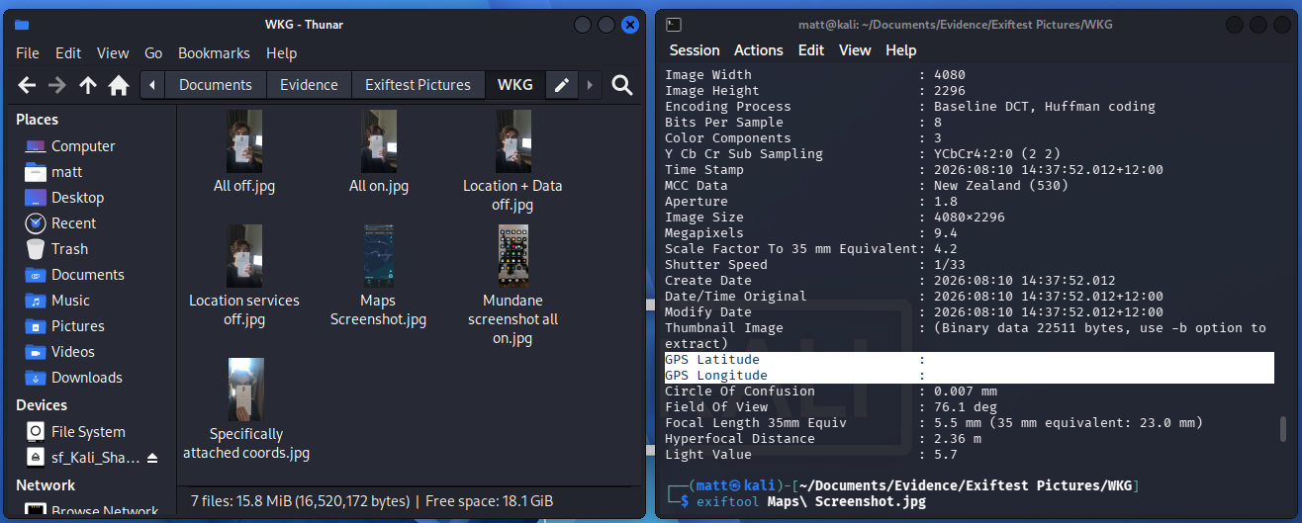
When I transfer the raw files over to my pc, I can view the gps data with exiftool if it is intentionally attached to the source image (this is spoofed)
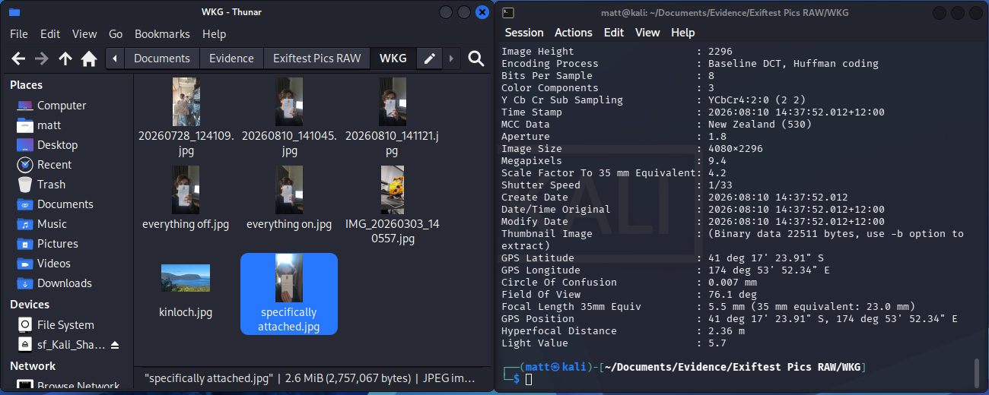

Tuesday, August 11
1:00-4:00pm (3hrs)
Essentially seeing if I can have the AI augmented incident response investigation manager “Valhuntir“ running in a capacity that functions within our testing environment (kali) and with the types of datasets that work with our traditional tools.
Valhuntir should work with lmstudio as it is considered a Model Context Protocol (MCP) client
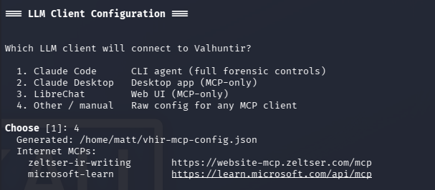
Underwent some troubleshooting due to having to increase storage space with gparted for lmstudio on account of the lowest footprint version of Valhuntir being 30gb.
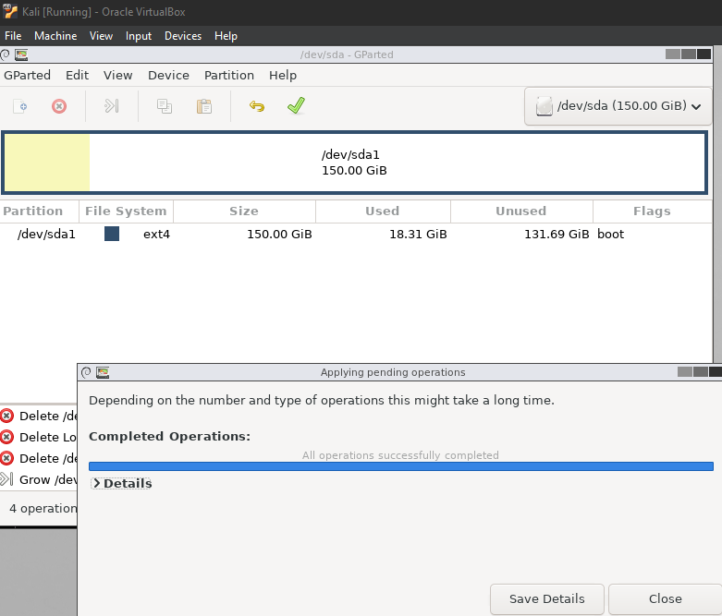
Managed to get lmstudio installed
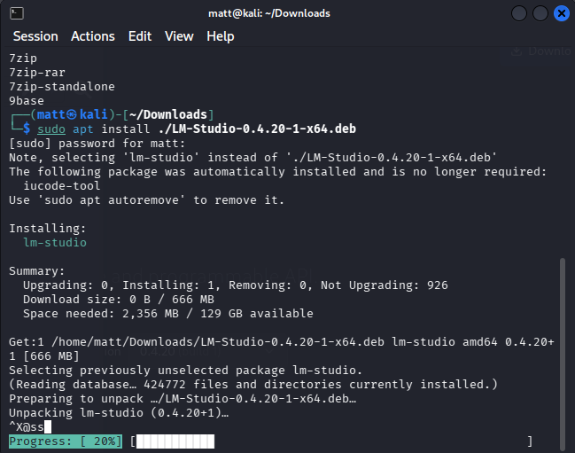
Wednesday, August 12
12:00-3:00PM (3hrs)
Consulting the Valhuntir documentation I realise that it is only supported by the SIFT Workstation OS and not Kali, I will try another tool (Unearth) on kali
Reading unearth documentation instructions, updating python 3, and ensuring I have Unearth’s dependencies
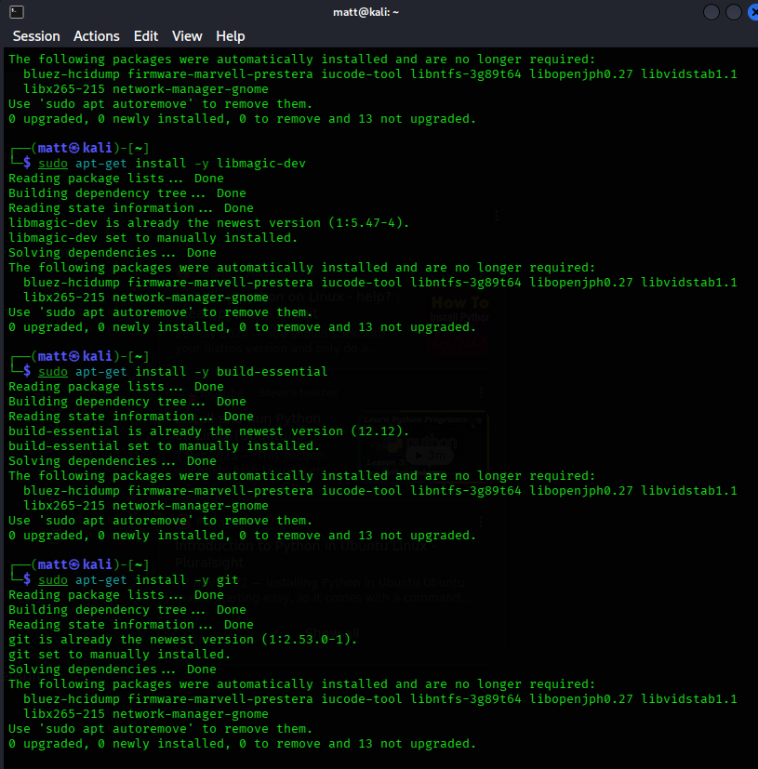
Cloning the unearth repository and creating a virtual environment because the program is written in python
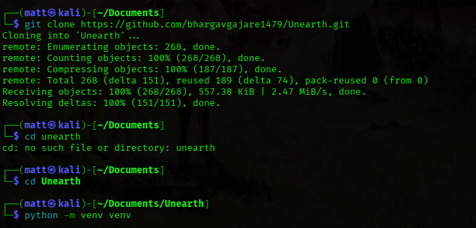

Unearth running successfully in my environment!
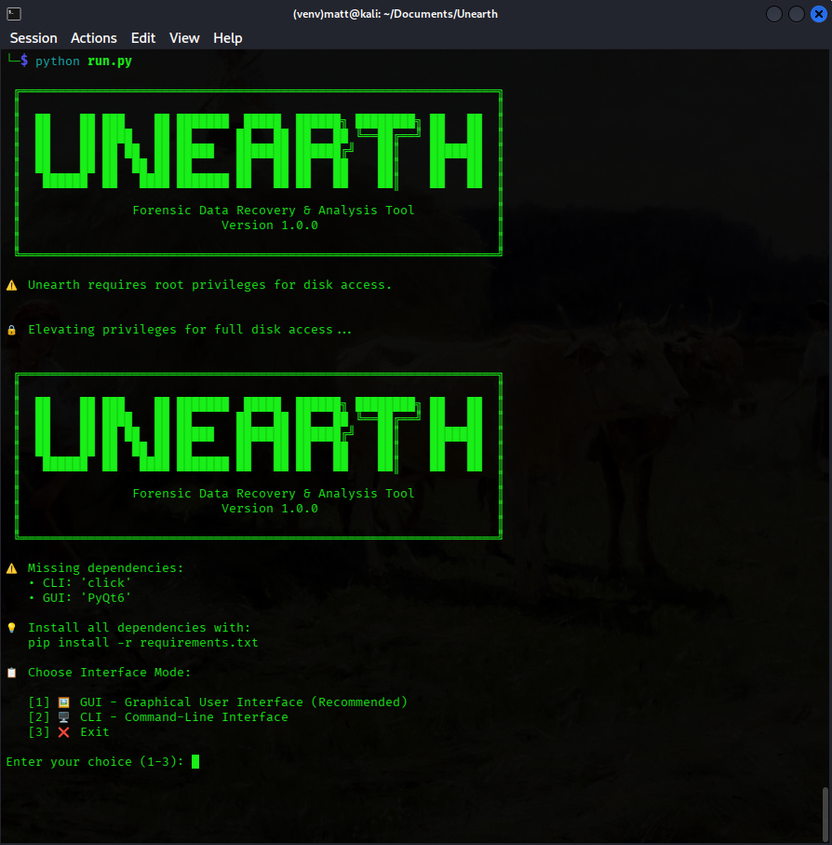
Installed and ran the GUI
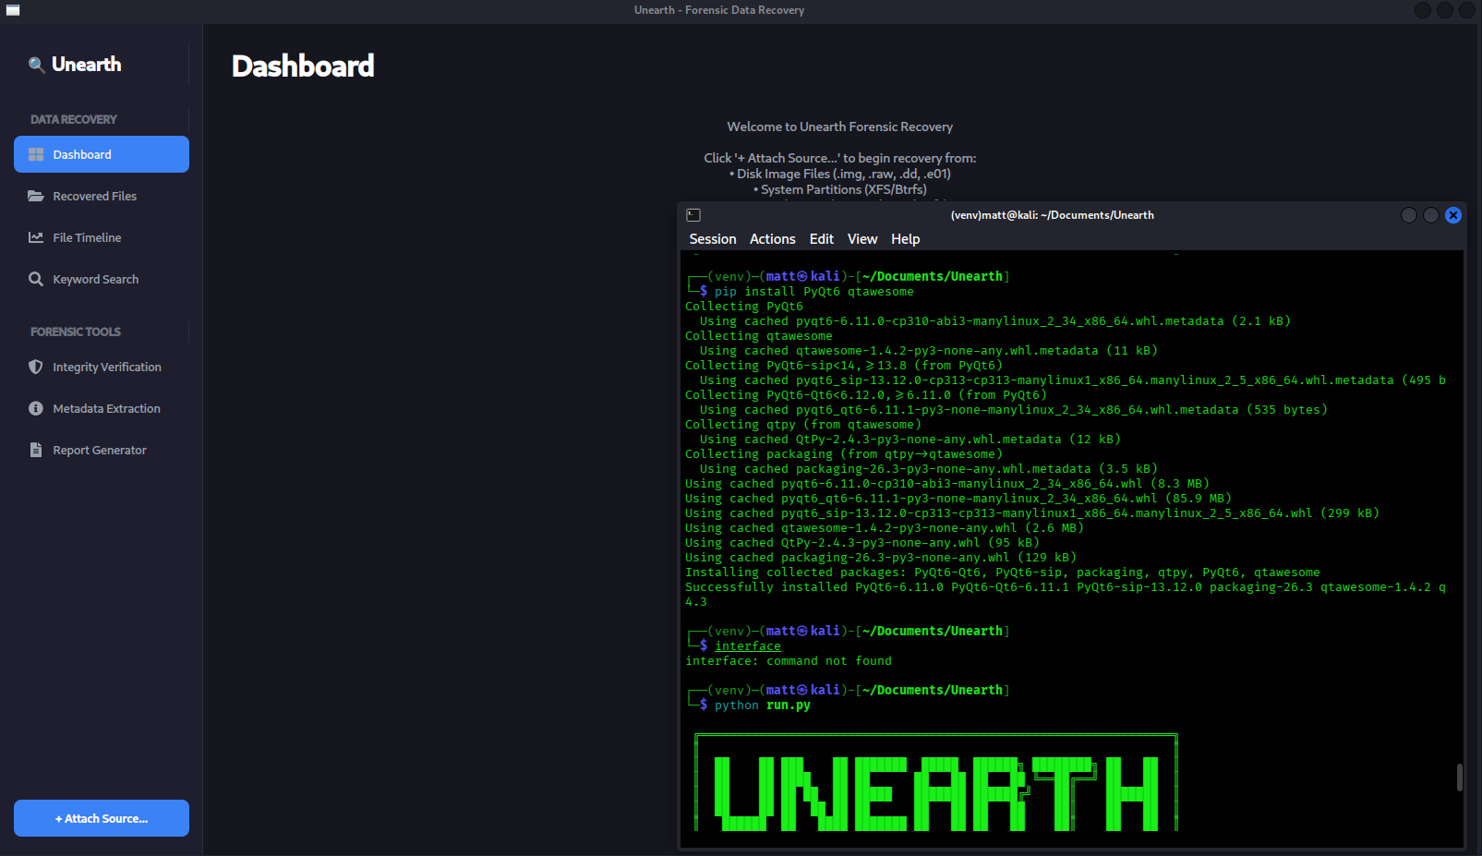
The application crashes when you try to add a data source, this is apparently due to DBus errors related to running with elevated permissions, and yet the application requires root privileges for disk access, even if you only permit a user disk access, the app still crashes. I spent a lot of time just troubleshooting. The errors point to the raised privilege causing a DBus failure which breaks the GUI.
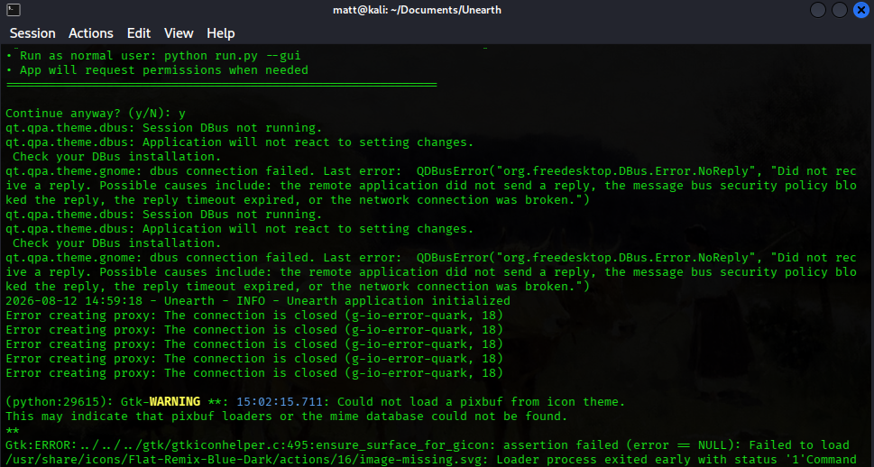

Thursday, August 13
1:15-3PM (1hr 45 mins)
Testing VPN connection to our remote machine at school, as well as what happens when two of us try to log in remotely in parallel. Installing unearth, dependencies, and LMStudio, spent a lot more time trying to get this tool specifically to work. Even the CLI version will not work. Also tried the automatic install through the cURL link as they use in their video demo demonstration.
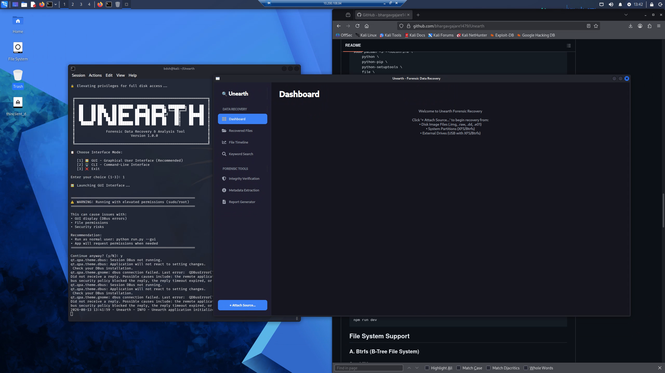
What’s interesting is their own video demo has the same DBus error I get, which rules this out as the fatal cause
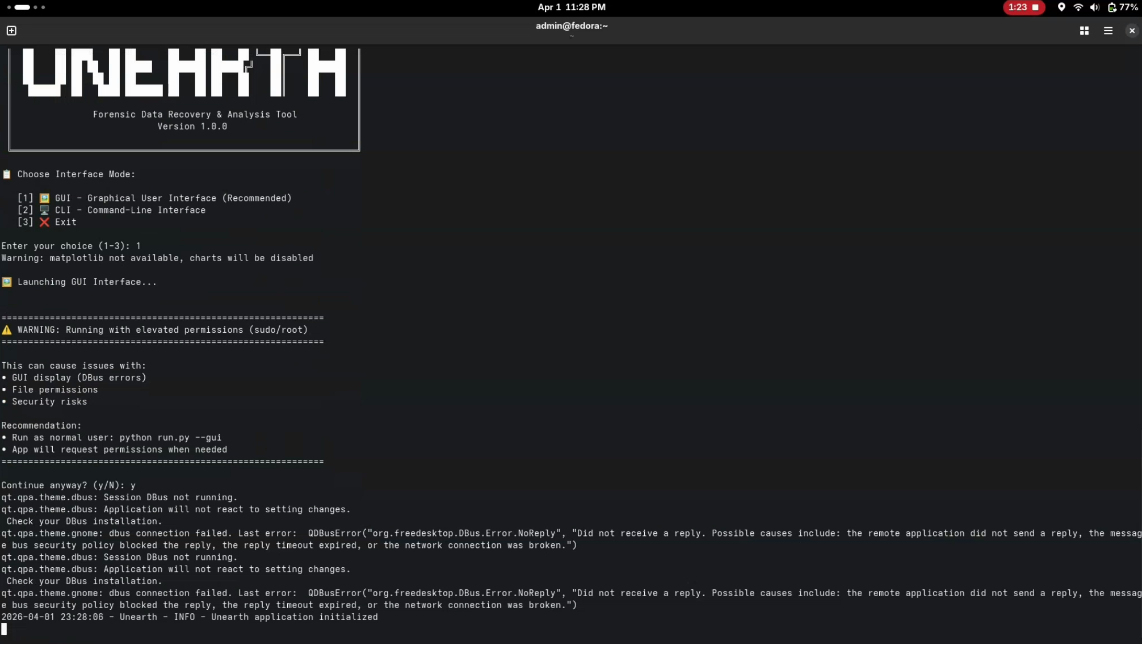
Friday. August 14
12-2:00PM (2 hrs)
On my home PC, attempting to get the AI powered forensics platform “Mulder” to run on kali which requires:
Flatpak/flathub to extract/install podman desktop
Docker/Podman
Ollama to run locally hosted AI models

Installed flatpack software deployment software in order to acquire podman
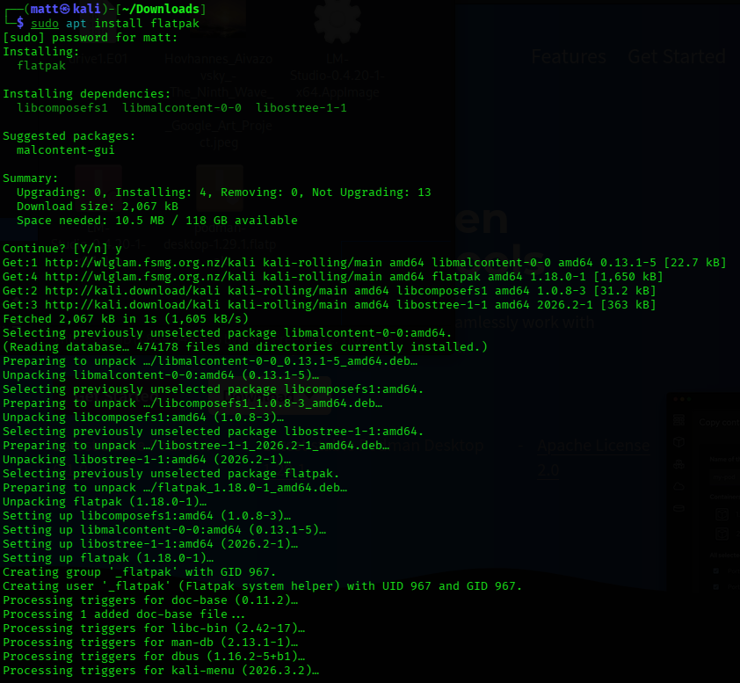
This error required me to update the flatbuh repo and install the 25.08 runtime from there before installing podman
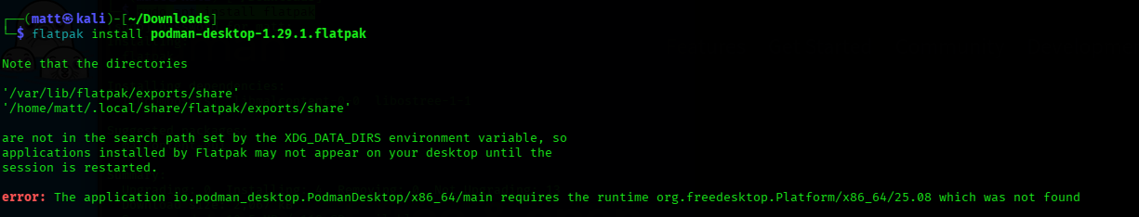
sudo apt install flatpak
sudo flatpak remote-add flathub https://dl.flathub.org/repo/flathub.flatpakrepo - update the flathub repo
flatpak install flathub org.freedesktop.Platform//25.08
flatpak install podman-desktop-1.29.1.flatpak
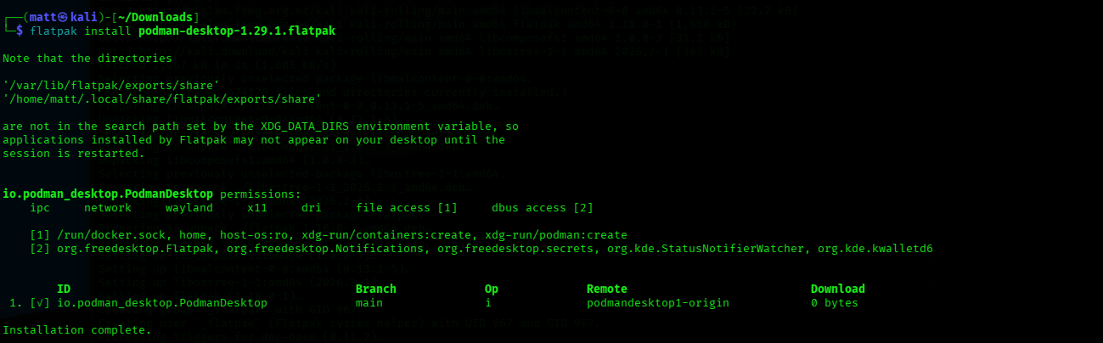
Pulling the container image:
podman pull ghcr.io/calebevans/mulder:1.3
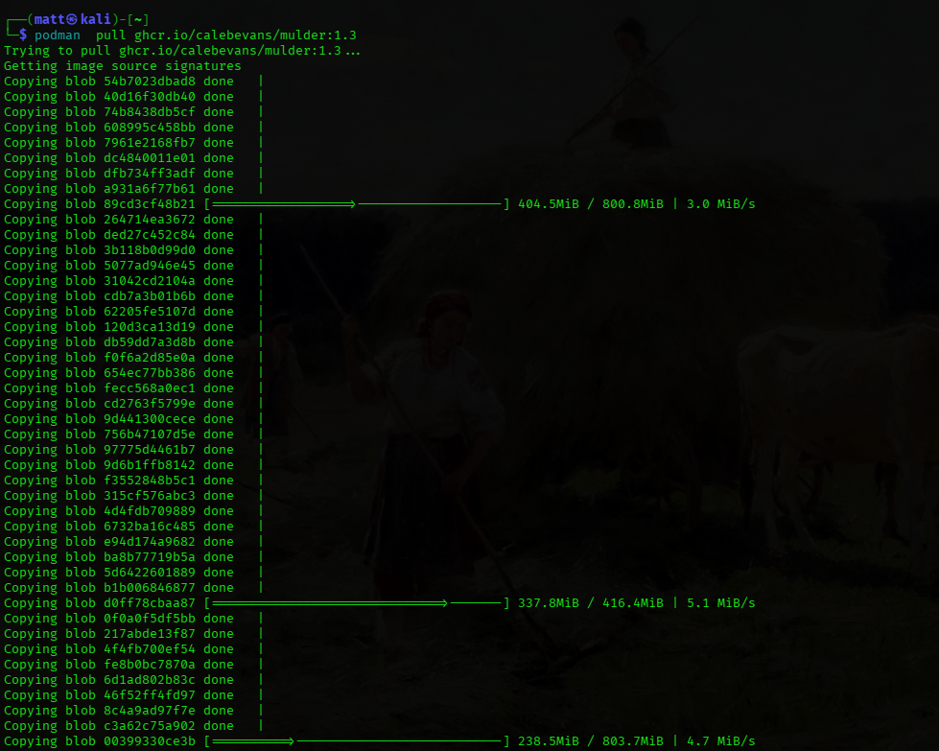
3:00-4:30PM (1hr 30min)
Decide to remote desktop connect through the vpn to test mulder on our actual AI host on campus due to my home pc’s vm not containing the adequate gpu power to serve a model through Ollama
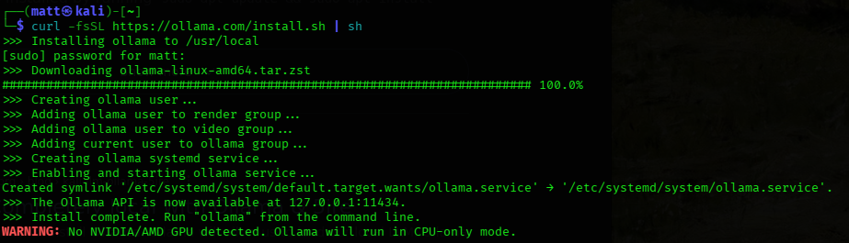
I have repeated the steps documented above on the campusPC.
Creating cases directory for mulder cases
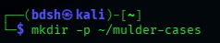
Installed ollama
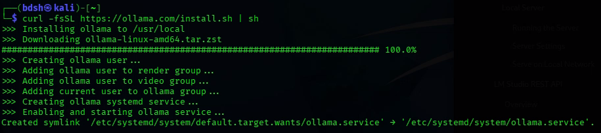

Downloading and testing the “Gemma4:26b” AI model within ollama
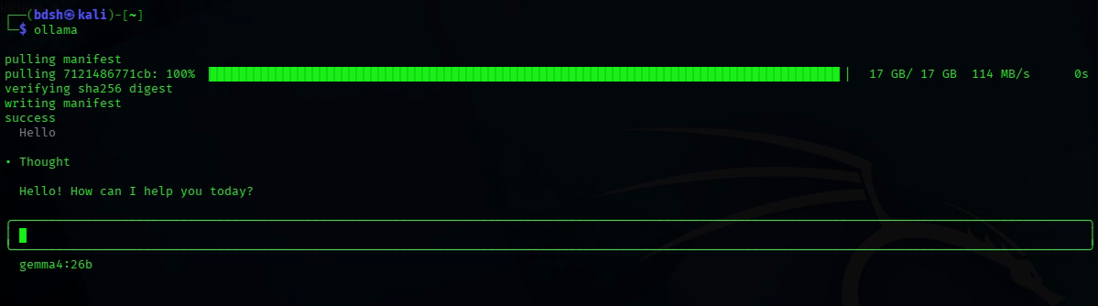
Unfortunately kept I kept running into this error, and struggled to find an answer or an alternative syntax
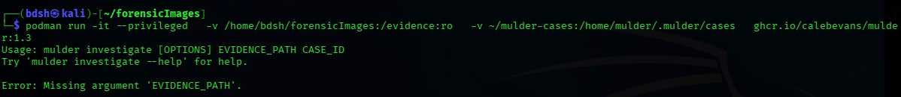
Saturday, August 15
11:00AM-12:30PM (1hr 30 mins)
Attempting to fix the problem from yesterday with mulder, had some success trying the –entrypoint flag which overrides the default executable to run (mulder) when the container starts, although mulder’s UI is forced to start, errors point to the same conclusion which is that my evidence path is misconfigured.
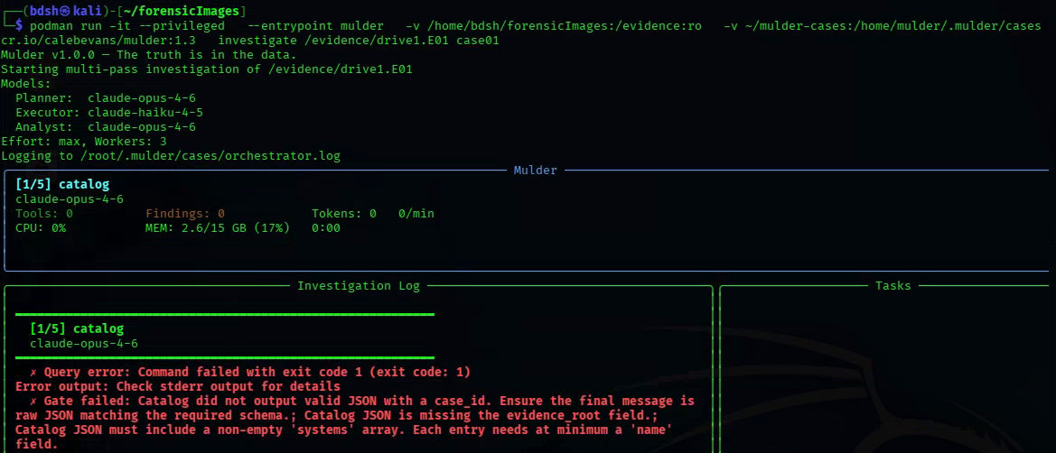

Trying to pass the ollama prefix anyway appears to show that mulder cannot access my ollama on port 4000 through the LiteLLM proxy, documentation states that the ollama server needs to be accessible from inside the mulder container via “host networking”, which is just a flag.
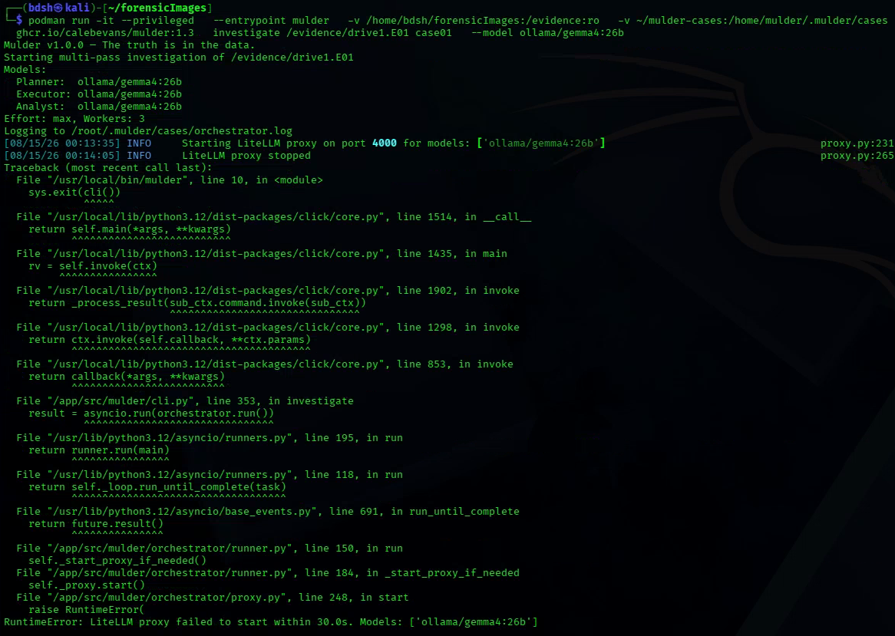
Running with –network host flag does not work, also litellm does not show up on netstat as it attempts to start
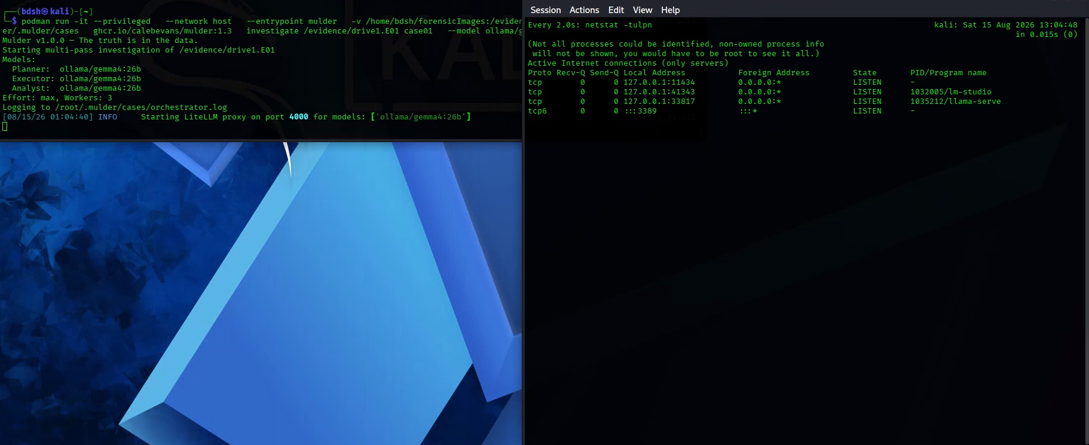
7:30PM-8:00PM (30mins)
Testing that LiteLLM proxy is able to connect to Ollama on my home pc’s VM, even though that model isn’t present, but still fails to connect on the actual machine that can run gemma4.
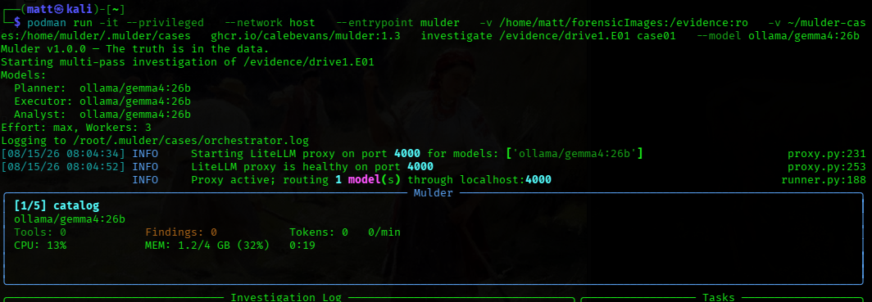
Also tried opening port 400 with ufw, running as sudo
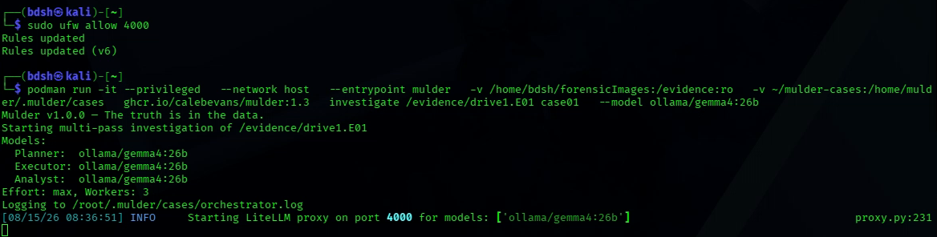
Sunday, August 16
1:00-3:00PM (2hrs)
I tried restarting the remote desktop, restarting various services, trying mulder 1.3.0/1.3.2 as well as creating and referencing a config file for litellm to follow so it can locate ollama on localhost outside of the container, custom litellm conifgurations are supported by mulder
https://github.com/calebevans/mulder/blob/main/docs/usage-guide.md
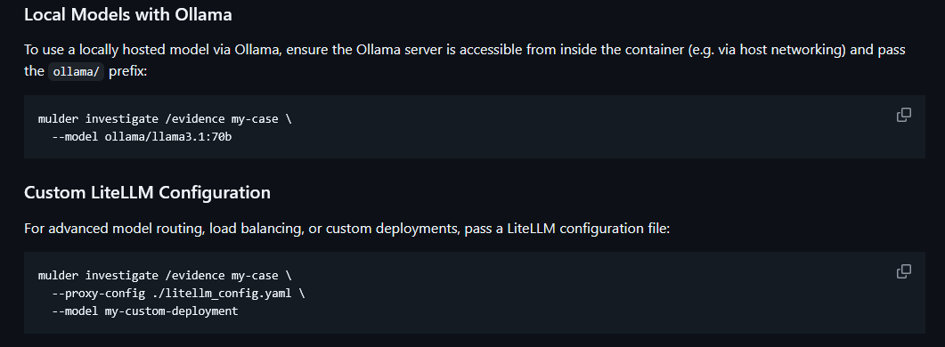
I passed the config into the container to see if mulder can read it from within, then tested to see if running an investigation with the proxy config passed will work, it does not.
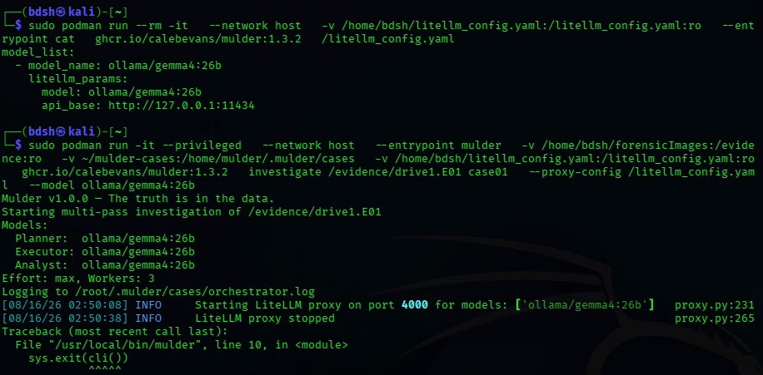
4:30 – 5:00PM (30 min)
Testing the functionality of “sherloq” the picture analysis tool, which interested me as it has “optional AI dependencies”.
Of course, after preparting the dependencies and virtual environment, I cannot get it to work
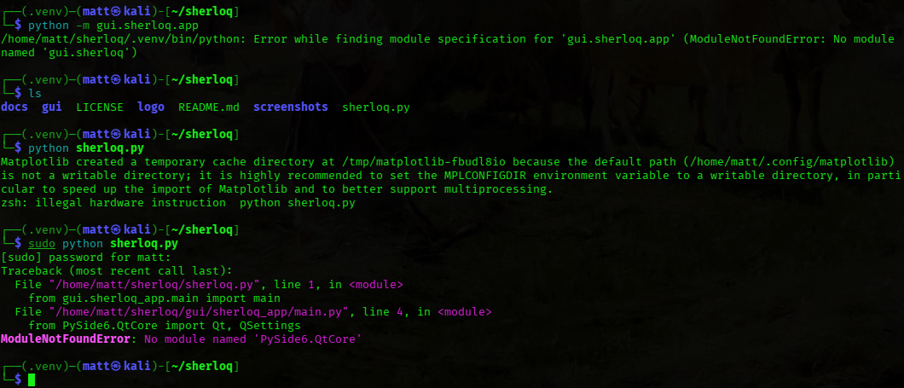

Development

